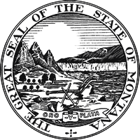 | Notice of Method of Counting Absentee Ballots

Absentee ballots will be publicly counted on election day starting at 12:00 p.m. at the following location(s): Musselshell County Court House, 506 Main Street, Roundup MT 59072, as specified in 13-15-201, MCA, by the following method(s):

[] counting by a voting system

[] by election judges appointed to count absentee ballots

[] Any person observing the procedures of the count must be sequestered with the board until the polls are closed and is required to take the oath provided in 13-15-207(4), MCA.

